ROUTINE REMINDER APP
@CREATIVITY THINK (9483175986/7019689991)

ABSTRACT:
Routine Reminder App is a web-based system designed to help users create, manage, and track daily or weekly routines efficiently. The platform provides automated reminders, progress tracking, and dashboard analytics for better routine adherence. Users can set personal or team routines, receive alerts, and monitor completion rates, while administrators can add or manage routines, moderate usage, and analyze performance metrics. Built with Django and Django Rest Framework on the backend and React with axios and recharts on the frontend, the system ensures timely notifications, transparent progress tracking, and a user-friendly interface for enhanced productivity..

INTRODUCTION OF THE PROJECT:
Maintaining consistent routines is often challenging for individuals, children, and teams due to forgetfulness, disorganization, or lack of structured monitoring. Routine Reminder App addresses these challenges by providing a centralized platform for creating schedules, sending alerts, and tracking completion progress. The system helps users stay organized and disciplined, while administrators can monitor engagement, moderate content, and generate analytics for actionable insights. This solution improves personal productivity, team coordination, and overall routine adherence..

PROJECT OBJECTIVES:

• Allow users to create daily or weekly routines
• Provide automated reminder alerts for scheduled tasks
• Enable tracking of routine completion and progress
• Offer dashboard analytics for user and admin insights
• Allow administrators to add, manage, and moderate routines
• Send targeted alerts for routine adherence and engagement
• Ensure secure and reliable backend operations
• Support analytics-driven decision-making for better productivity

PROBLEM OF THE STATEMENT:
Individuals and teams often struggle with maintaining consistent routines due to a lack of reminders and structured tracking. Manual methods of routine management are prone to forgetfulness, errors, and lack of accountability. Administrators have no efficient means to monitor engagement or moderate routine content. Routine Reminder App resolves these issues by providing a centralized, automated, and interactive system for routine scheduling, reminders, tracking, and analytics, ensuring better adherence and productivity..

MOTIVATION OF THE PROJECT:
• To help users manage routines effectively
• To provide timely alerts for scheduled tasks
• To improve personal and team productivity
• To maintain transparent progress tracking
• To empower administrators with dashboard analytics
• To moderate usage and maintain structured routines
• To promote accountability and adherence to schedules

BLOCK DAIGRAM OF PROJECT:

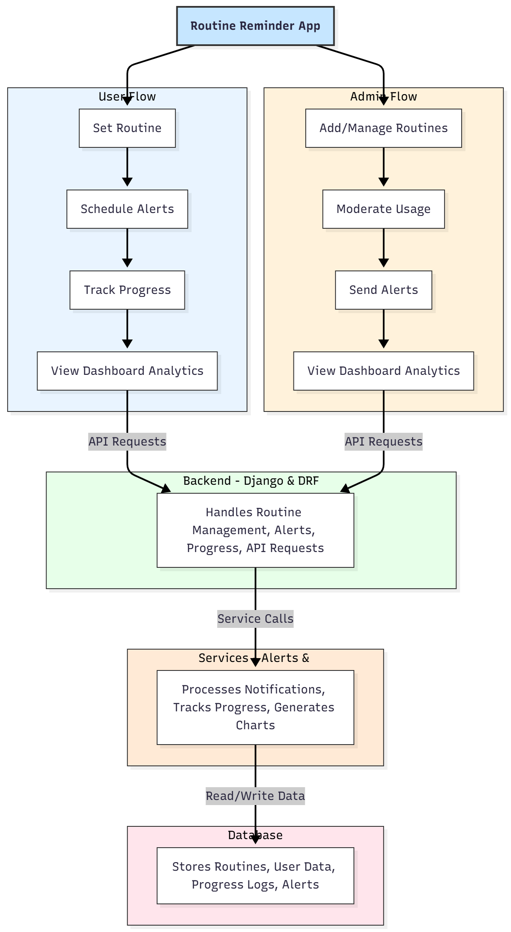

WORKING OF THE PROJECT:
The system allows users to create routines specifying tasks, frequency, and timing. Alerts are automatically generated and sent at scheduled times. Users can track progress, mark tasks as complete, and view analytics on routine adherence. Administrators add or manage routines, moderate content to ensure relevance, and analyze usage through dashboards. The backend handles routine storage, alert scheduling, and API communication, while services track progress and generate charts. The database stores all routines, user data, alerts, and progress logs to maintain seamless operation and reporting..

SOFTWARE REQUIREMENT:
- Backend:
  - Python 3.x
  - Django
  - Django REST Framework
  - SQLite/PostgreSQL
- Frontend:
  - Node.js and npm
  - React.js
  - Axios
- Development Tools:
  - Visual Studio Code
  - Postman (for testing APIs)
  - Git/GitHub (for version control)
- Server/Deployment (Optional):
  - Gunicorn, Nginx, or Heroku/AWS for hosting

ADVANTAGES OF THE PROJECT:

• Automates routine scheduling and reminders
• Tracks progress with visual analytics
• Reduces forgetfulness and enhances adherence
• Provides admin moderation for structured usage
• Supports personal, children, and team routines
• Improves productivity and accountability
• Generates actionable insights via dashboards
• Scalable for individual and organizational use

APPLICATIONS OF THE PROJECT:
• Personal routine management
• Kids’ schedule tracking
• Team productivity and coordination
• Health and fitness routines
• Study schedules for students
• Workplace task tracking

REFERENCES:

- Django REST Framework Documentation — Django Software Foundation. Django Documentation. Available: https://docs.djangoproject.com/
- Django REST Framework. DRF Documentation. Available: https://www.django-rest-framework.org/
- React. React Official Documentation. Available: https://reactjs.org/docs/getting-started.html
- Redux. Redux Documentation. Available: https://redux.js.org/introduction/getting-started
- PostgreSQL Global Development Group. PostgreSQL Documentation. Available: https://www.postgresql.org/docs/
- MySQL. MySQL Reference Manual. Available: https://dev.mysql.com/doc/
- Git. Git Documentation. Available: https://git-scm.com/doc
- Node.js. Node.js Documentation. Available: https://nodejs.org/en/docs/
- Axios. Axios Documentation. Available: https://axios-http.com/docs/intro
- Socket.io Documentation – https://socket.io/docs/

